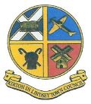

Kirton in Lindsey Town Council
Town Council Office, Town Hall, High Street, Kirton in Lindsey, North Lincolnshire, DN21 4LZ
e-mail: enquiries@kirtoninlindseytowncouncil.gov.uk telephone: 01652 648978
website: www.kirtoninlindseytowncouncil.gov.uk
October 2019 Newsletter

A brief update on activities and news from Kirton in Lindsey Town Council.

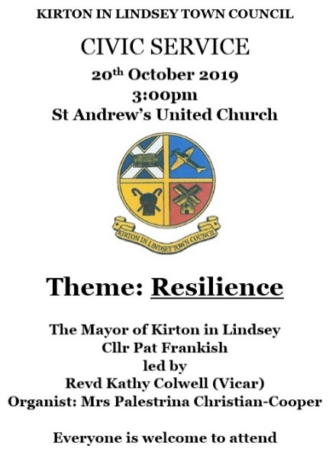
Civic Service - Resilience
This month has included the annual Civic Service, held at St Andrew's United Church followed by a buffet reception at the Town Hall. The event was very well attended equally by Civic Dignitaries from North Lincolnshire, North East Lincolnshire, West Lindsey & East Riding of Yorkshire and groups, organisations and residents from the town.
The guard of honour into St Andrew’s United Church and then on to the Town Hall was led by the Cadet detachment, brownies, beavers, cubs and scouts. The theme of this year’s service was Resilience represented by the words spoken and sung during throughout. A collection was taken for sharing jointly between the Mayor's Charity this year, the Garden of Edward Elmhirst Duckering and St Andrew's United Church.
A very welcome reception of refreshments was then served by the Terrace Bistro and Tea Room.
Thank you to all who attended to celebrate Kirton in Lindsey.
The boundary between the Green and
the Garden of Edward Elmhirst Duckering
After a prolonged period of decision making and necessary arrangements, the old concrete bollards along the boundary between the two lands held in trust by the Town Council, the Green and the Garden of Edward Elmhirst Duckering were this month replaced with new bollards to make the area safer. The new bollards also provide a more appropriate marking out of the different areas of land.
The area on the War Memorial side ("The Garden") is also under consideration of development as a Peace Garden as previously promoted by the Town Council with call for comments and suggestions - thank you to everyone who responded. The Mayor is looking to raise funding throughout this year to enable works to begin on the design and installation, making the Garden a feature to compliment the War Memorial monument.
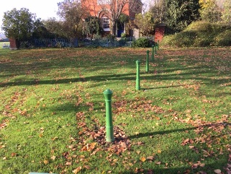 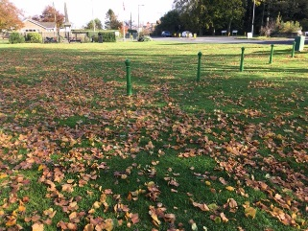
Remembrance Sunday - 10th November 2019
Please be aware road closures will again take place during the Remembrance Day Service at the War Memorial on Sunday 10th November. South Cliff Road, North Cliff Road, King Edward Street and Redbourne Mere will all be temporarily closed to traffic so that the silence and service can be heard by those gathered at the memorial.
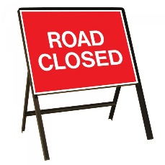
Bench commemorating the Diamond Jubilee - Market Place
The Town Council has replaced the plaque of dedication on the bench opposite the Town Hall in the Market Place due to damage and subsequent removal of the original plaque. The wording of the new plaque remains the same.
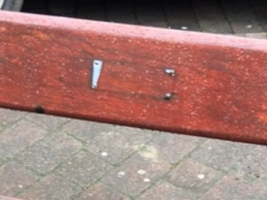 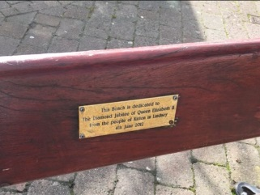
Grove Street Cemetery
As you may have noticed over the summer, the Town Council applied for a Faculty from the Diocese of Lincoln to carry out memorial stone 'topple testing' within the cemetery to ensure that the cemetery remains safe and memorial stones structurally sound. The Faculty was approved this month following no objections received from members of the public and work will begin in due course.
In addition, the posts for the taps in the cemetery were replaced this month with further work carried out to protect the water pipes feeding the taps from the winter weather.
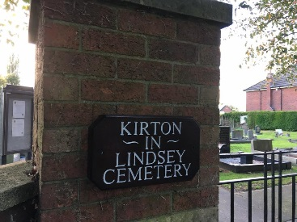
Christmas Festival 2019
Don't forget the annual Christmas Festival including the Christmas Lights Switch On and stalls in the Market Place and inside the Town Hall will take place at the end of next month, on Sunday 24th November. The event will start at 3:30pm and the countdown to the lights switch on will be from 5pm. Santa will arrive in the Market Place around 4pm to meet the children and listen to what they would like to receive for Christmas this year. There will be a wide range of stalls to browse and the schedule for entertainment will be published soon - we hope to see you there! Please remember that there will be a requirement to implement road closures around Sylvester Street, High Street and George Street to enable the event to take place and we apologise for any inconvenience this may cause on the 24th November.
In Brief
The Town Council has approached the Community Speedwatch Co-ordinator for further details on the Community Speedwatch Scheme which trains volunteers and provides them with the equipment to monitor the speeds of traffic along the towns roads. If you are interested in this scheme, please get in touch!
There are a number of live building developments around the town, and the Town Council has received approach from each one to put forward suggestions for the future names of these streets. If you have ideas for the names of future streets in the town, please let the Town Council know so that these can be included in any further consultation approaches.

Kirton in Lindsey Town Council, October 2019
www.kirtoninlindseytowncouncil.gov.uk
email: enquiries@kirtoninlindseytowncouncil.gov.uk
telephone: 01652 648978
address: Town Council Office, Town Hall, High Street, Kirton in Lindsey, North Lincolnshire, DN21 4LZ
Public drop in sessions at the Town Council office Tuesdays and Thursdays between 12-4pm.
The Clerk is available to meet at other times by appointment.

